HARROGATE, 22nd November 2022
FOR IMMEDIATE RELEASE
Local start-ups set for bright future…
Fourteen local businesses seem set for a great future. All fourteen have recently completed StriveLive, a two-month start-up incubator, with five businesses picking up awards and £2,500 in grant funding. The project was open to residents of Harrogate Borough Council and City of York Council areas, or those setting up business there.
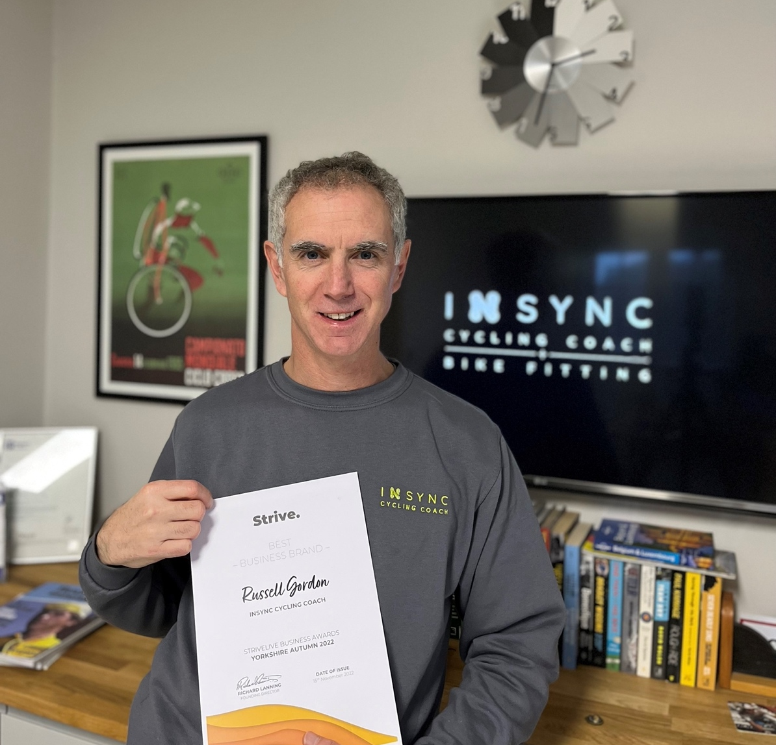
“I’m really thrilled to win the Strive Best Brand Award. The recognition and confidence the award brings along with everything I’ve learnt on the Strive project, makes me far better equipped to really grow the business.”
Russel Gordon, founder of InSync Cycling Coach.
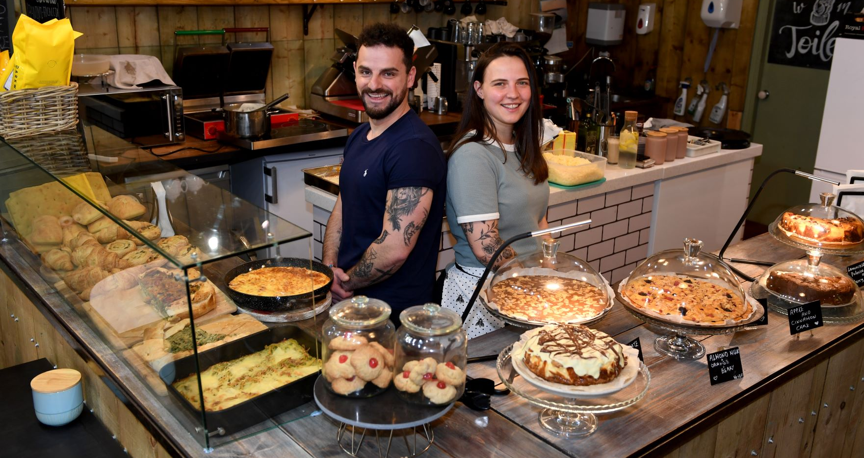
“Strive is an amazing place to learn absolutely everything you need to know about business. But most importantly Paul, Richard and Laura work very hard and they are always available for any questions or concerns we had. We really enjoyed it and we have learned a lot from the project.”
Daniela Genova founder of Café Lago di Como,
pictured with partner Nertil Xhallo
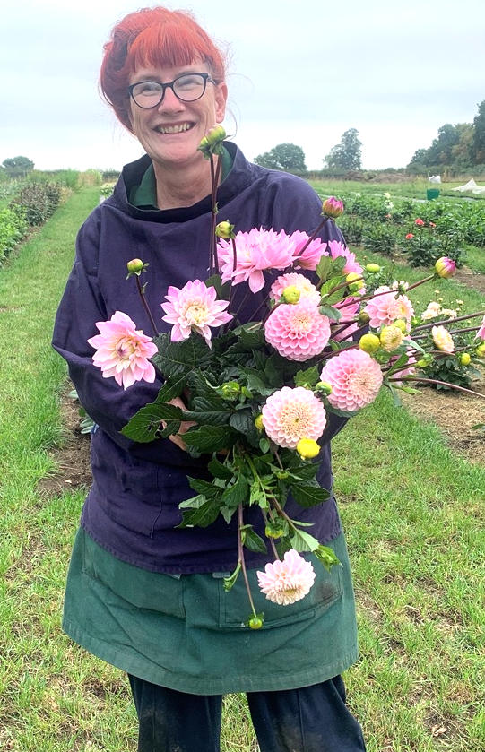

"I encourage anyone who is nurturing their small business idea to sign up for Strive. The project will benefit everyone on their business journey. Engaging sessions delivered in a friendly and encouraging environment.
Plus, you get to meet likeminded people, which is fabulous."
Andrea Clarke,
Founder of Hand Sown Flowers

Three business experts were invited to judge Branding, Marketing, Concept and Strategy categories in which each winner scooped a £500 business grant. It was no easy task, judges saw an incredible range of businesses and talented local entrepreneurs. When the judging concluded a cycling coach, Russell Gordon, Harrogate café, Lago di Como, massage therapist, Abigail Homer, and first aid trainer Yvonne Lewis and Andrea Clarke who cultivates hand-sown flowers had come out on top.
The Strive project was funded by Harrogate Borough Council and City of York Council commissioned by the York & North Yorkshire Growth Hub.

- ENDS –

- CONTACT -
Contact Enterprise CUBE/Strive:
Name: Laura Mumford
Phone: +44 (0)74000 50 876
Central: 08081968015
Website: www.homeofstrive.com/harrogate
Email: laura@homeofstrive.com

Award winners
Yvonne Lewis won Best Business Concept for Wise First Aid Training which offers a range of first aid training, including courses for parents and toddlers.
(Tel: 07858200601 – www.wisefirstaid.co.uk)
Daniela Genova and Nertil Xhallo won Best Marketing for Café Lago di Como, a café in the centre of Harrogate offering award winning Italian cuisine.
(Tel: 07588 032540 www.lagodacomo.com)
Russell Gordon won Best Brand for Insync Cycling Coach which offers coaching, bike fitting and is supporting the Northeast Cyclocross Championships.
(Tel: 07490958136 –www.insynccyclingcoach.com)
Abigail Homer won a Strive Start-Up award for The Therapy Room Thirsk which offers a range of massages. (Tel: 07855259092 - www.thetherapyroomthirsk.co.uk)
Andrea Clarke won Best Strategy for Hand-Sown Flowers which cultivates flowers locally for weddings and florists. (Tel: hand-sown.flowers@outlook.com)

Judges
Hanna Dilley, Founder, Benji’s Bites
Susan Brandom, Inward Investment Officer, Harrogate Borough Council
Karen Booth, Business Relationship Manager YNY Growth Hub

- FURTHER INFORMATION -
Strive projects are run by the social enterprise, Enterprise CUBE CIC, who use their profits to support disadvantaged entrepreneurs across the UK.
Strive was first run in 2012.
Strive has supported over 5,000 people in the UK.
Strive has won Community Impact Awards from National Housing Federation 2013 and TPAS 2020.
Director, Laura Mumford, has won the Young Achiever of the Year Award in Leadership, 2016, for managing the social enterprise Our Croydon and Pantene Shine Strong Award, 2017, for women excelling in business leadership roles.
This Strive project was commissioned by the York & North Yorkshire Growth Hub and funded by both Harrogate Borough Council and City of York Council.

