HARROGATE, 11th April 2022
FOR IMMEDIATE RELEASE

Local businesses wow dragons…
…winning £2,500 in Funding!

Fourteen local people recently grabbed the opportunity to team up with some start-up experts to give their business dreams a boost. They joined StriveLive, a start-up incubator which guided them through a series of workshops, advice sessions and start-up challenges before they competed to impress business experts at the project finale to win £2,500 in prizes at the end of the seven-week project.
Four business experts were invited to judge and award prizes in 5 categories. These friendly ‘dragons’ were, Ben Gill, Innovation Manager National Grid; Katy Norton, Head of Buying Hobbycraft; Emily MacDowell, Principal Economic Growth Officer Harrogate Borough Council and Karen Booth, Business Relationship Manager YNY Growth Hub.
Karen Allen, from Kidzplay Play Box picked up two awards winning Most Customer Orientated and Best Business Concept. With years of experience running preschool sessions in play centres, Karen co-founded Kidzplay Play Box during lockdown, with play centre owner Lisa Mee. They put their creativity into an activity box for children. You may have spotted Kidzplay at Springtime Live recently. You can also find Kidzplay boxes stocked in local farm shops like Fodder and a variety of garden centres across the county, with plans to launch a subscription service soon!
Karen said, “Strive popped up on my social media at a point when I was searching for support with the business. I was looking to get to know other entrepreneurs in the local area, looking to increase my knowledge and understand how I could move the business forward. Strive gave me the confidence to move forward, the understanding to face the challenges, and the connections within the local area to continue the support after the course finished. Strive for me allowed me to step up, to move on…with the supportive team and experienced entrepreneurs with years of experience, knowledge and stories.”
Hanna Dilley, founder of Benji’s Bites Toddler Food, really impressed the panel of judges, picking up commendations in Most Customer Orientated, Best Branding, and winning Best Marketing. You can find Benji’s Bites stocked locally in Crimple Foodhall, or on Benji’s Bites Toddler Food’s website.
Hanna who is no stranger to winning awards having recently being voted the best meal delivery for babies and kids in the Evening Standard Best List, said, “I really enjoyed the Strive course, the subjects we discussed, and meeting fellow local business owners. Starting and running a food business by yourself is really tough so it’s great to connect with other people going through similar challenges as me, and share ideas. I’m delighted to have won the prize for ‘Best Marketing’, the prize will enable me to reach more busy parents in need of a helping hand at toddler mealtimes!”
Oliver Brown’s business, Wrapd Studios, was awarded Best Branding by the dragons. Ollie has been running a mobile valeting business for a year but is about to open the doors to his new business venture on Knaresborough business park. Wrapd Studios will be offering vehicle customisation and vehicle protection.
Ollie said, “Thank you very much to all the team at Strive for all your help on my business journey. I’m lucky to have found what I’m passionate about at just 18…to put it simply making cars look as good as possible, for as long as possible.”
Claire Parish, from Four Legs Pet Care, and Graham Dodds from GMD Home Improvements both picked up Strive Start-Up awards.
A trained veterinary nurse, Claire is starting a dog boarding business on her family’s farm. Taking just one ‘dog family’ at a time, offering beautiful views, and a stress-free environment, Claire hopes this unique offer will be popular with dog owners and their pets too. As well as winning an award, the judges also commended Claire in the Best Business Concept category.
Graham’s business GMD Home and Garden Improvement, offers a reliable and quality, handyman service. Graham has built an excellent reputation within just a short few months and has an order book full until the summer. As well as picking up an award, Graham was also commended by the judges in the Best Marketing category.
“This has been one of the most impressive set of businesses we’ve ever worked with, it was truly a difficult task for the judges to pick winners as the businesses and entries were all so strong!”, says Laura Mumford, 33, part of the team running the project. “As a Yorkshire lass, I might be biased, but Harrogate is lucky to have these inspirational people starting a wonderful range of businesses locally.”
The StriveLive Harrogate project was supported by Harrogate Borough Council, using Government COVID-19 business recovery funding, and commissioned by the York and North Yorkshire Growth Hub. Any local businesses looking for support, can find similar projects and help via the York and North Yorkshire Growth Hub (https://www.ynygrowthhub.com/).

- ENDS –

- CONTACT -
Contact Enterprise CUBE/Strive:
Name: Laura Mumford
Phone: +44 (0)74000 50 876
Central: 08081968015
Website: www.homeofstrive.com/harrogate
Email: laura@homeofstrive.com

Contact Everything in a Box/Kidz-Play
Name: Karen Allen
Website: https://everythinginabox.co.uk/
Email: karenallensnest@ntlworld.com

Award winners
Karen Allen won Most Customer Orientated and Best Business Concept and £1,000 in funding.
Hanna Dilley won Best Marketing and £500 in funding.
Oliver Brown won Best Branding and £500 in funding
Claire Parish won a Strive Start-Up award, and £250 in funding.
Graham Dodds won a Strive Start-Up award, and £250 in funding.

Award Winners Business links:
Everything in a Box/Kidz-Play:
https://everythinginabox.co.uk/
https://www.facebook.com/KidzplayPlayBox
https://www.instagram.com/kidzplay.box/

Benji’s Bites:
https://www.benjisbites.co.uk/
https://www.instagram.com/benjisbitesuk/

Wrapd Studios:
https://www.wrapdstudios.com/
https://www.instagram.com/wrapdstudios/

Four Legs Pet Care:
www.fourlegspetcare.wordpress.com
https://www.facebook.com/fourlegspetcare

GMD Home Improvement:
https://www.facebook.com/GMDHomeandGarden/

- FURTHER INFORMATION -
Strive projects are run by the social enterprise, Enterprise CUBE CIC, who use their profits to support disadvantaged entrepreneurs across the UK.
Strive was first run in 2012.
Strive has supported over 5,000 people in the UK.
Strive has won Community Impact Awards from National Housing Federation 2013 and TPAS 2020.
Director, Laura Mumford, has won the Young Achiever of the Year Award in Leadership, 2016, for her directorships in two award winning social enterprises and the Pantene Shine Strong Award, 2017, for women excelling in business leadership roles.
This Strive project was commissioned by the York and North Yorkshire Growth Hub, and supported by Harrogate Borough Council, using Government COVID-19 business recovery funding.

- PHOTOS –

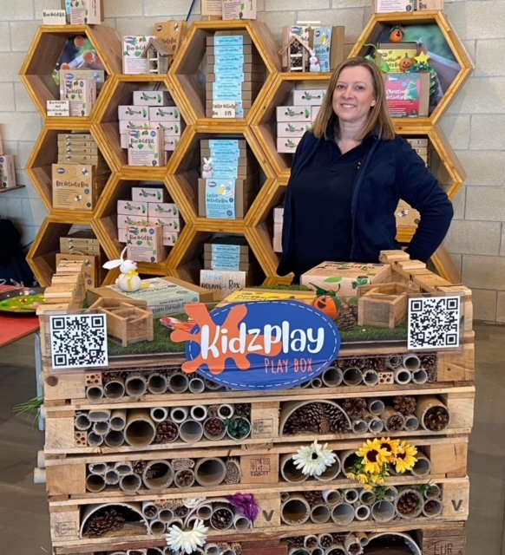

Karen Allen, co-founder of KidzPlay, and winner of Best Business Concept and Most Customer Orientated business.
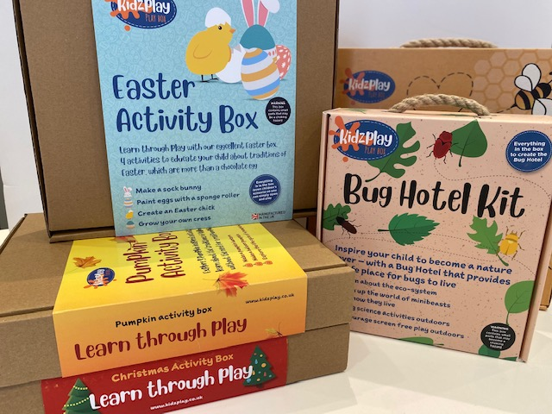

Kidzplay activity boxes.

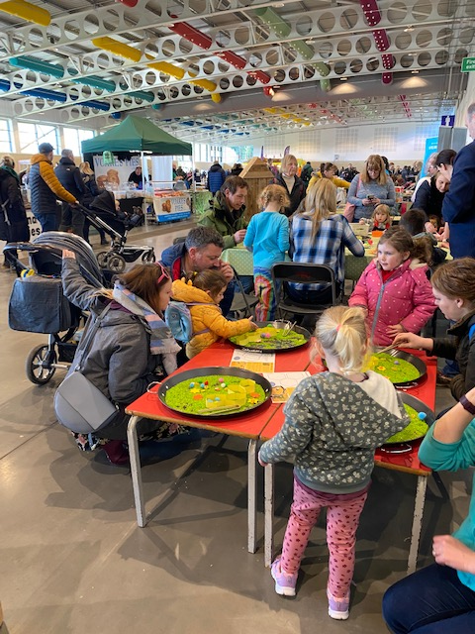

Kidzplay at this year’s Springtime event.

Hanna Dilley, Founder of Benji’s Bites Toddler Food, winner of Best Marketing.

Benji’s Bites Toddler Food.

Benji’s Bites Toddler Food.

Ollie’s new business, Wrapd Studios, on Knaresborough Business Park.

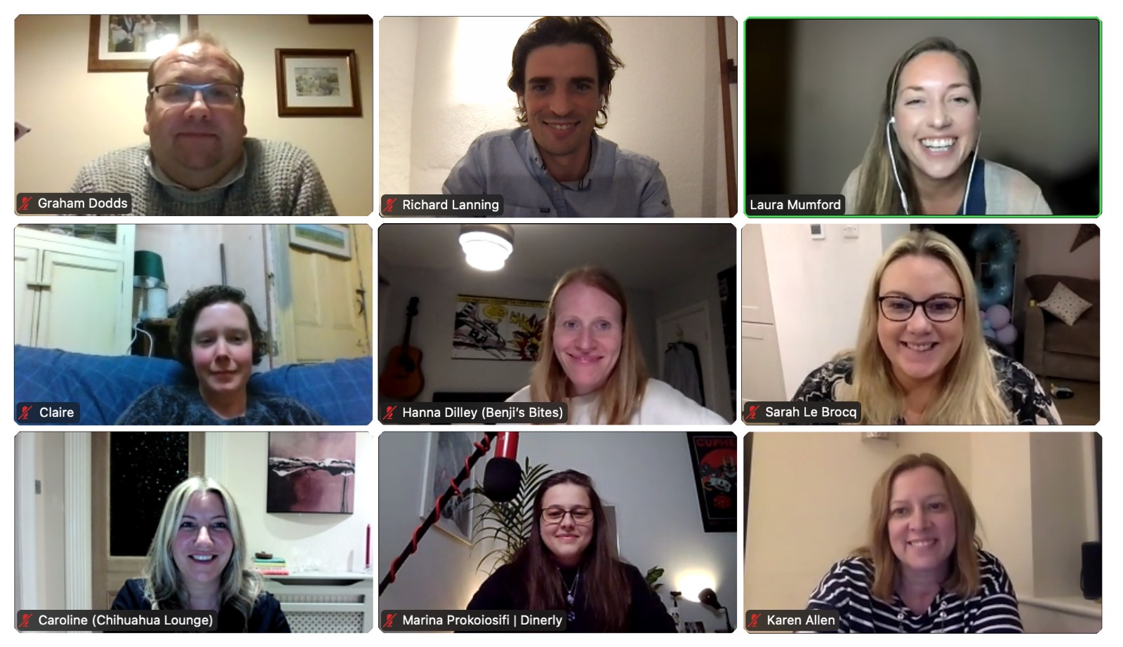

StriveLive Group sessions were held via Zoom, but the group plan to meet up locally too.

